UNITED STATES
SECURITIES AND EXCHANGE COMMISSION
WASHINGTON, D.C. 20549

FORM 8-K

CURRENT REPORT
Pursuant to Section 13 or 15(d) of the Securities Exchange Act of 1934
Date of Report (Date of earliest event reported): July 15, 2026


Pediatrix Medical Group, Inc.
(Exact name of Registrant as Specified in Its Charter)

Florida |  |  | 001-12111 | 26-3667538
(State or Other Jurisdiction  of Incorporation) |  |  | (Commission File Number) | (IRS Employer  Identification No.)
1301 Concord Terrace
Sunrise, Florida |  |  |  | 33323
(Address of Principal Executive Offices) |  |  |  | (Zip Code)

Registrant’s Telephone Number, Including Area Code: 954 384-0175

(Former Name or Former Address, if Changed Since Last Report)

Check the appropriate box below if the Form 8-K filing is intended to simultaneously satisfy the filing obligation of the registrant under any of the following provisions:
☐Written communications pursuant to Rule 425 under the Securities Act (17 CFR 230.425)
☐Soliciting material pursuant to Rule 14a-12 under the Exchange Act (17 CFR 240.14a-12)
☐Pre-commencement communications pursuant to Rule 14d-2(b) under the Exchange Act (17 CFR 240.14d-2(b))
☐Pre-commencement communications pursuant to Rule 13e-4(c) under the Exchange Act (17 CFR 240.13e-4(c))
Securities registered pursuant to Section 12(b) of the Act:
Title of each class |  | Trading  Symbol(s) |  | Name of each exchange on which registered
Common Stock, par value $.01 per share |  | MD |  | The New York Stock Exchange
Indicate by check mark whether the registrant is an emerging growth company as defined in Rule 405 of the Securities Act of 1933 (§ 230.405 of this chapter) or Rule 12b-2 of the Securities Exchange Act of 1934 (§ 240.12b-2 of this chapter).
Emerging growth company ☐
If an emerging growth company, indicate by check mark if the registrant has elected not to use the extended transition period for complying with any new or revised financial accounting standards provided pursuant to Section 13(a) of the Exchange Act. ☐

Item 2.02 Results of Operations and Financial Condition.
On July 15, 2026, Pediatrix Medical Group, Inc., a Florida corporation (the “Company”), issued a press release providing an update for the Company’s recently completed second quarter (the “Press Release”). A copy of the Press Release is furnished as Exhibit 99.1 to this Current Report on Form 8-K and is incorporated by reference into this Item 2.02.

Item 7.01 Regulation FD Disclosure.
Exhibit 99.1 is incorporated by reference into this Item 7.01.
The information contained in Items 2.02 and 7.01 of this Current Report on Form 8-K and the Exhibit 99.1 is furnished and shall not be deemed “filed” for purposes of Section 18 of the Securities Exchange Act of 1934, as amended (the “Exchange Act”), or incorporated by reference in any filing under the Securities Act of 1933, as amended, or the Exchange Act, except as may be expressly set forth by specific reference in any such filing, regardless of any general incorporation language in the filing.

Item 9.01 Financial Statements and Exhibits.
d) Exhibits.
Exhibit Index
99.1— Press Release of Pediatrix Medical Group, Inc. dated July 15, 2026.

SIGNATURES
Pursuant to the requirements of the Securities Exchange Act of 1934, the registrant has duly caused this report to be signed on its behalf by the undersigned hereunto duly authorized.
 |  |  | Pediatrix Medical Group, Inc.
Date: | July 15, 2026 | By: | /s/ Kasandra H. Rossi
Kasandra H. Rossi
Chief Financial Officer

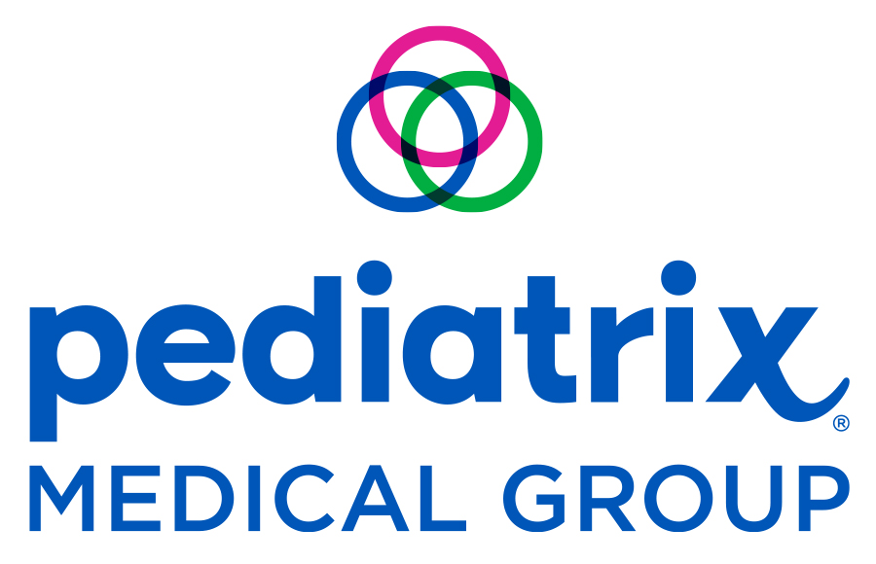

FOR MORE INFORMATION:
Kasandra H. Rossi
Executive Vice President, Chief Financial Officer & Treasurer
954-692-7163
kasandra.rossi@pediatrix.com

FOR IMMEDIATE RELEASE

Pediatrix Medical Group Provides Second Quarter Update

FORT LAUDERDALE, Fla., July 15, 2026 - Pediatrix Medical Group, Inc. (NYSE: MD) (“Pediatrix” or “the Company”), a leading provider of physician services, today provided an update on its second quarter 2026 business trends.
In response to recent reports from other healthcare market participants regarding shifting utilization and reimbursement trends, the Company confirms that its payor mix for the second quarter remained stable and unchanged relative to recent historical trends and the Company’s internal expectations. To date, Pediatrix has not experienced the unfavorable payor mix shifts reported elsewhere in the healthcare sector. In addition, Pediatrix has not seen material changes in other net revenue-related trends compared to recent historical periods.
Pediatrix reaffirms its previously reported full year 2026 outlook for Adjusted EBITDA, and anticipates Adjusted EBITDA will be in a range of $280 million to $300 million.
Earnings Conference Call
Pediatrix will host an investor conference call and webcast on Tuesday, August 4, 2026 at 9:00 a.m. ET to discuss results from operations for the quarter ended June 30, 2026. A detailed press release will be issued the morning of August 4, 2026 before the securities markets open.
The investor conference call will be webcast and can be accessed at Pediatrix’s website, www.pediatrix.com/investors.
Non-GAAP Measures

A reconciliation of projected full year 2026 Adjusted EBITDA to the most directly comparable GAAP financial measures is provided in the financial table of this press release.

ABOUT PEDIATRIX MEDICAL GROUP
Pediatrix® Medical Group, Inc. (NYSE:MD) is a leading provider of physician services. Pediatrix-affiliated clinicians are committed to providing coordinated, compassionate and clinically excellent services to women, babies and children across the continuum of care, both in hospital settings and office-based practices. Specialties include obstetrics, maternal-fetal medicine and neonatology complemented by multiple pediatric subspecialties. The group’s high-quality, evidence-based care is bolstered by significant investments in research, education, quality-improvement and safety initiatives. The physician-led company was founded in 1979 as a single neonatology practice and today provides its highly specialized and often critical care services through approximately 4,300 affiliated physicians and other clinicians. To learn more about Pediatrix, visit www.pediatrix.com or follow us on Facebook, Instagram, LinkedIn and the Pediatrix blog. Investment information can be found at www.pediatrix.com/investors.

Certain statements and information in this press release may be deemed to contain forward-looking statements within the meaning of the Private Securities Litigation Reform Act of 1995, Section 27A of the Securities Act of 1933, as amended (the “Securities Act”), and Section 21E of the Securities Exchange Act of 1934, as amended. Forward-looking statements may include, but are not limited to, statements relating to the Company’s objectives, plans and strategies, its full year 2026 guidance, future impacts of legal, regulatory, political and macroeconomic developments and all statements, other than statements of historical facts, that address activities, events or developments that we intend, expect, project, believe or anticipate will or may occur in the future. These statements are often characterized by terminology such as “believe,” “hope,” “may,” “anticipate,” “should,” “intend,” “plan,” “will,” “expect,” “estimate,” “project,” “positioned,” “strategy” and similar expressions, and are based on assumptions and assessments made by the Company’s management in light of their experience and their perception of historical trends, current conditions, expected future developments and other factors they believe to be appropriate. Any forward-looking statements in this press release are made as of the date hereof, and the Company undertakes no duty to update or revise any such statements, whether as a result of new information, future events or otherwise. Forward-looking statements are not guarantees of future performance and are subject to risks and uncertainties. Important factors that could cause actual results, developments, and business decisions to differ materially from forward-looking statements are described in the Company’s most recent Annual Report on Form 10-K and its Quarterly Reports on Form 10-Q, including the sections entitled “Risk Factors”, as well the Company’s current reports on Form 8-K, filed with the Securities and Exchange Commission, and include the following: completion of the Company’s second quarter closing process, the impact of the Company’s practice portfolio management plans and whether the Company is able to achieve the expected favorable impact to Adjusted EBITDA therefrom; the effects of economic conditions on the Company’s business; the effects of the Medicare Access and CHIP Reauthorization Act of 2015, the Affordable Care Act, the One Big Beautiful Bill Act and potential additional healthcare reform; the Company’s relationships with government-sponsored or funded healthcare programs and with managed care organizations and commercial health insurance payors and any shifts in the Company’s payor mix; the impact
2

of state budgetary constraints and uncertainty over the future of Medicaid; the impact of surprise billing legislation; the Company’s transition to a hybrid revenue cycle management model; the timing and contribution of future acquisitions or organic growth initiatives; the Company’s ability to comply with the terms of debt financing arrangements and the Company’s ability to replace, refinance or extend its current debt financing arrangements; and the effects of the Company’s transformation initiatives, including our renewed focus, and growth strategy for, the Company’s hospital-based and maternal-fetal service lines.

###

3

Pediatrix Medical Group, Inc.
Reconciliation of Net Income to Forward-Looking Adjusted EBITDA
(in thousands)
(Unaudited)

Year Ended
December 31, 2026
Net income |  | $ | 152,100 |  |  | $ | 166,700
Interest expense |  |  | 33,500 |  |  |  | 33,500
Income tax provision |  |  | 56,300 |  |  |  | 61,700
Depreciation and amortization expense |  |  | 24,800 |  |  |  | 24,800
Transformational and restructuring related expenses |  |  | 13,300 |  |  |  | 13,300
Adjusted EBITDA |  | $ | 280,000 |  |  | $ | 300,000

4

